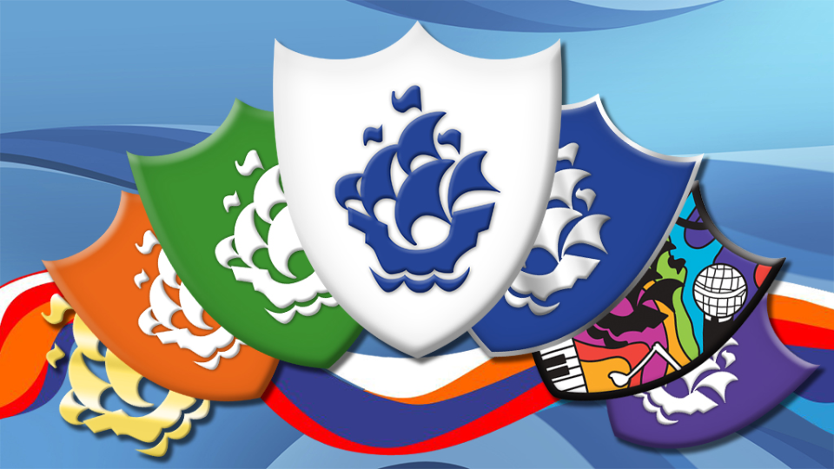***SCHOOL COUNCIL***

***BLUE PETER BADGE CHALLENGE 2024***

It is always very exciting when someone brings in a Blue Peter badge to share In our assemblies and now we would like to challenge you to win a badge. There are 8 different types of badges to win. If you achieve a Blue Peter badge this will gain you free entry to lots of attractions all over the country!

Blue badge- Blue badges are awarded for sending in interesting letters, stories, makes, pictures, poems, good ideas for the programme, and for having appeared on Blue Peter.

## Book badge- The new Book badge, was designed by one of the UK’s best known illustrators, Sir Quentin Blake. To earn your badge, share your thoughts on a favourite book, draw a character or scene and tell us about other books and writers that you love

Orange badge- Orange badges are given to winners and runners up of Blue Peter competitions. To have a chance of winning one of these badges you must enter a Blue Peter competition, which only run during certain times in the year.

## Green badge- Green badges are awarded for sending in letters, pictures and makes that are about the environment, conservation or nature.

Fan Club badge- Purple Fan Club badges are awarded for joining the Blue Peter fan club and answering some questions about the show and the website.

## The Silver badge – The Silver badge celebrates kindness and doing something for others. You could be doing something to make a difference in your community, speaking up for what you believe in, or helping a friend.

Music badge -The Music badge is a very special badge, designed by superstar Ed Sheeran. It's awarded to those who show off their passion for music by learning a new instrument or being part of a musical performance.

## Sport badge - The Sport badge is awarded for getting active and trying a sport that you have never tried before. Check out the amazing badge designed by none other than Leah Williamson, one of the biggest female football stars on the planet!

For more information visit the Blue Peter website

<https://www.bbc.co.uk/cbbc/joinin/about-blue-peter-badges>