Jacket potato | 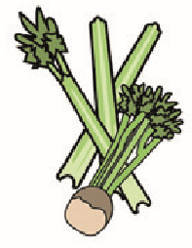 | 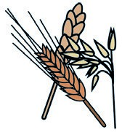 | 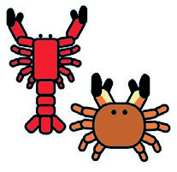 | 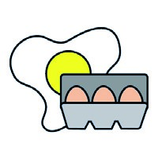 | 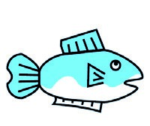 | 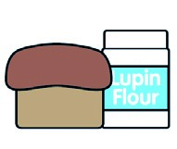 | 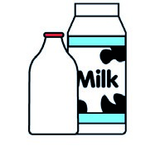 | 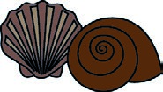 | 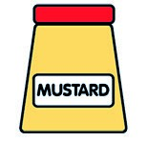 | 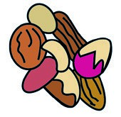 | 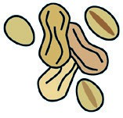 | 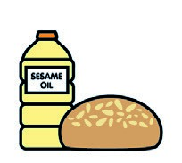 | 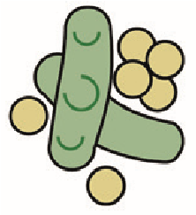 | 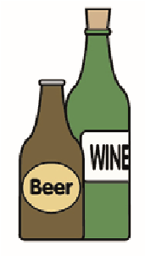
 | Celery | Cereals containing gluten** | Crustace. | Eggs | Fish | Lupin | Milk | Molluscs | Mustard | Nuts* | Peanuts | Sesame seeds | Soya | Sulphur dioxide
Jacket |  | Main c |  |  |  |  |  |  |  |  |  |  | x
coleslaw |  | Main c |  | x
butter |  | Main c |  |  |  |  | x
Tuna mayo |  | Main c |  | x | x
Ham/Ch |  | Main c |  |  |  |  | x
Chilli con c |  | Main c
Baked beans |  | Main c
Week 1 | Cereals containing | gluten | Crustaceans | Eggs | Fish | Lupin | Milk | Molluscs | Mustard | Nuts* | Peanuts | Sesame  seeds | Soya | Sulphur dioxide

