Christmas dinner | 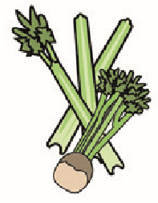 | 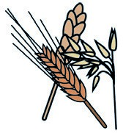 | 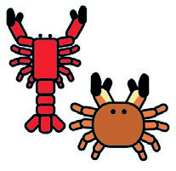 | 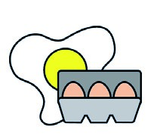 | 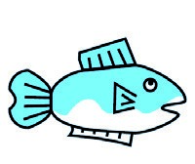 | 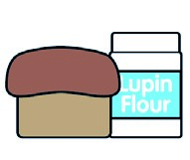 | 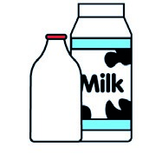 |  | 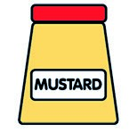 | 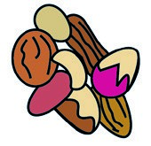 | 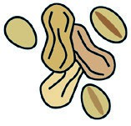 | 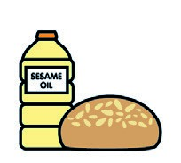 |  | 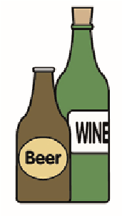
 | Celery | Cereals containing gluten** | Crustace. | Eggs | Fish | Lupin | Milk | Molluscs | Mustard | Nuts* | Peanuts | Sesame seeds | Soya | Sulphur dioxide
Turkey |  | Main c |  |  |  |  | x
Roast potato |  | Main c
Gravy |  | Main c
Pigs-in-blankets |  | Main c |  | x |  |  | x
parsnip |  | Main c
carrots |  | Main c
broccolie |  | Main c
stuffing |  | x |  |  |  |  | x
Chocolate muffins |  | x |  | x |  |  | x
Fruit |  | Main c
Craker’s & chees |  | x |  |  |  |  | x
Cheese cake |  | Main c |  |  |  |  | x
 | Cereals containing | gluten | Crustaceans | Eggs | Fish | Lupin | Milk | Molluscs | Mustard | Nuts* | Peanuts | Sesame  seeds | Soya | Sulphur dioxide
triffle |  | x |  | x |  |  | x
Chrismas biscutes |  | x |  | x |  |  | x |  |  |  | Main c

