Week 2 | 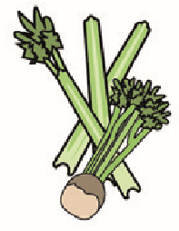 | 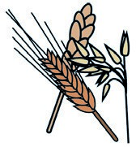 | 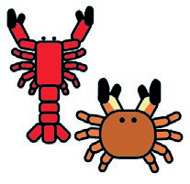 | 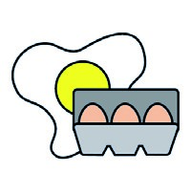 | 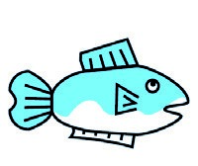 | 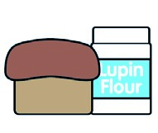 | 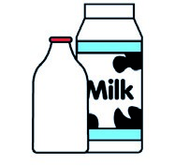 |  | 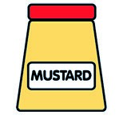 | 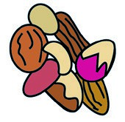 | 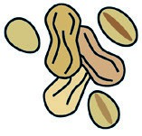 | 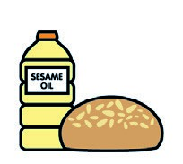 |  | 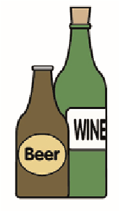
 | Celery | Cereals containing gluten** | Crustace. | Eggs | Fish | Lupin | Milk | Molluscs | Mustard | Nuts* | Peanuts | Sesame seeds | Soya | Sulphur dioxide
rice |  | May C
Jam tart |  | x |  | x |  |  | x
Veg rissoto |  | x |  |  |  |  | x
yoghurts |  | May C |  |  |  |  | x
Jacket |  | May C |  |  |  |  | x
Chicken  curry |  | x |  |  |  |  | x
wedges |  | May C
Veg dolmades |  | x |  |  |  |  | x
Ice cream |  |  |  |  |  |  | x
sausages |  | x |  | x
Fresh potato |  | May C |  |  |  |  | x
Fruit crumble |  | x |  |  |  |  | x
Week 1 | Cereals containing | gluten | Crustaceans | Eggs | Fish | Lupin | Milk | Molluscs | Mustard | Nuts* | Peanuts | Sesame  seeds | Soya | Sulphur dioxide
Jacket & cheese & butter |  | May C |  |  |  |  | x
cream |  | May C
Cottage pie |  | May C
Fish cake |  | x |  |  | x |  | x
Macaroni cheese |  | x |  |  |  |  | x
Mix beans casserole |  | x |  |  |  |  | x
Strawberry cheesecake |  | May C |  |  |  |  | x

