Week 3 | 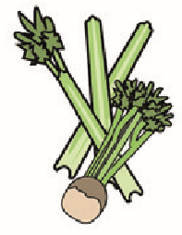 | 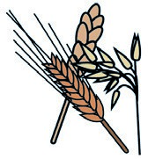 | 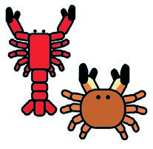 | 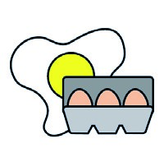 | 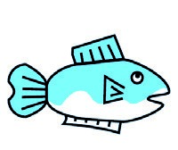 | 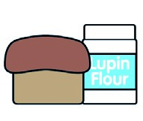 | 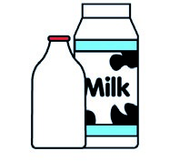 |  | 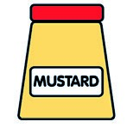 | 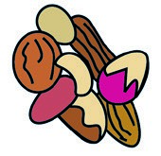 | 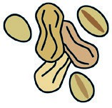 | 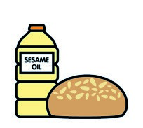 |  | 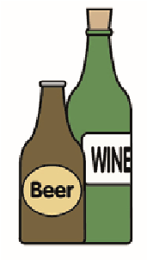
 | Celery | Cereals containing gluten** | Crustace. | Eggs | Fish | Lupin | Milk | Molluscs | Mustard | Nuts* | Peanuts | Sesame seeds | Soya | Sulphur dioxide
Chicken nuggets |  | x |  | x
wedges |  | main c
Veg burger |  | x |  | x |  |  | x
Bun |  | x
Jam tart |  | x |  | x |  |  | x
Pizza |  | x |  |  |  |  | x
Salad |  | Main c
Roasted fish tortilla |  | x |  | x | x |  | x
Jelly |  | Main c |  |  |  |  | x
Ice cream |  | Main c |  |  |  |  | x
peaches |  | Main c
Beef lasagne |  | x |  | x |  |  | x
Week 3 | Cereals containing | gluten | Crustaceans | Eggs | Fish | Lupin | Milk | Molluscs | Mustard | Nuts* | Peanuts | Sesame  seeds | Soya | Sulphur dioxide
Creamy spaghetti |  | x |  |  |  |  | x
Fruit crumble |  | x |  |  |  |  | x
Fresh cream |  | Main c |  |  |  |  | x
Roast gammon |  | Main c
Roast potato |  | Main c
h/ch toastie |  | x |  |  |  |  | x
Veg tofu toastie |  | x
flapJack |  | x |  |  |  |  | x
Chorizo pasta |  | x |  |  |  |  | x
Veg Medley Pie |  | x |  | x |  |  | x
Chocolate cake |  | x |  | x |  |  | x
Chocolate sauce |  | Main c |  |  |  |  | x
Jacket potato |  | Main c |  |  |  |  |  |  |  |  |  |  | x
Seasonal veg |  | Main c

