Week 3  christmas | 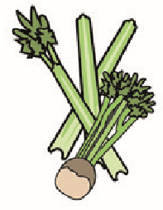 | 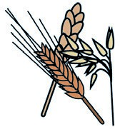 | 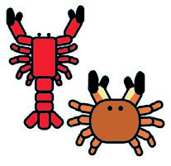 | 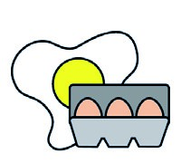 | 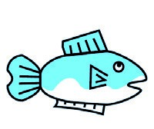 | 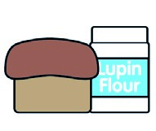 | 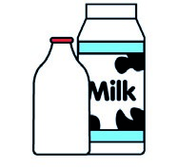 |  | 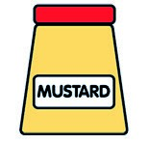 | 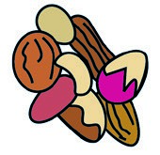 | 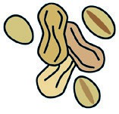 | 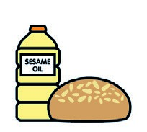 | 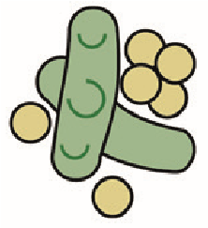 | 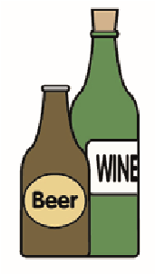
 | Celery | Cereals containing gluten** | Crustace. | Eggs | Fish | Lupin | Milk | Molluscs | Mustard | Nuts* | Peanuts | Sesame seeds | Soya | Sulphur dioxide
Chick nuggets |  | x |  |  |  |  | x
Veg nuggets |  | x |  |  |  |  | x
Beef lasagne |  | x |  | x |  |  | x
Veg lasagne |  | x |  | x |  |  | x
Fresh potato |  | Main con. |  |  |  |  | x
Sausages casserole |  | x
Fruit crumble |  | x |  |  |  |  | x
Cream |  | Main con. |  |  |  |  | x
Spaghetti bolognese |  | x |  |  |  |  | x
pasta |  | x
Rice |  | Main con.
Jelly & fruit |  | Main co.
Week 1 | Cereals containing | gluten | Crustaceans | Eggs | Fish | Lupin | Milk | Molluscs | Mustard | Nuts* | Peanuts | Sesame  seeds | Soya | Sulphur dioxide
Veg pasta |  | x |  |  |  |  | x
Jacket potato |  | Main. con |  |  |  |  | x
Crakers cheese |  | x |  |  |  |  | x
Fish fingers |  | x |  |  | x |  | x
Wedges |  | Main con.
Yoghurts |  |  |  |  |  |  | x
Veg fish fingers | x | x |  |  |  |  | x
Surprise pudding |  | x |  | x |  |  | x

