Sandwich  Filling  Pack lunch | 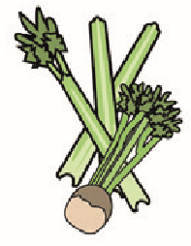 | 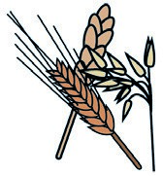 | 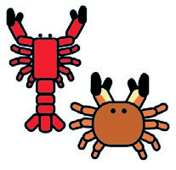 | 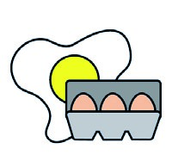 | 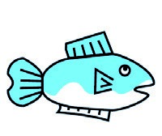 | 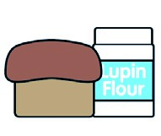 | 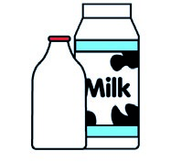 |  | 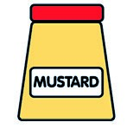 | 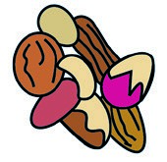 | 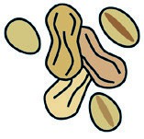 | 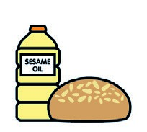 |  | 
 | Celery | Cereals containing gluten** | Crustace. | Eggs | Fish | Lupin | Milk | Molluscs | Mustard | Nuts* | Peanuts | Sesame seeds | Soya | Sulphur dioxide
HAM |  | Main c
Cheese |  | Main c |  |  |  |  | X
Tuna mayo |  | Main c |  | X | X
Jam |  | Main c
h/ch |  | Main c |  |  |  |  | X
Chicken  mayo |  | Main c |  | X
Yogh |  | main c |  |  |  |  | X
Fruit |  | Main c
Pudding |  | Main c
Raisins
Christmas cookies |  | x |  | x |  |  | x |  |  |  | Main c
Week 1 | Cereals containing | gluten | Crustaceans | Eggs | Fish | Lupin | Milk | Molluscs | Mustard | Nuts* | Peanuts | Sesame  seeds | Soya | Sulphur dioxide

